**GROCERY WEBSITE**

**By**

**Santosh**

**Seshu naidu**

**Nl.satya**

## NAME OF THE CANDIDATE(S)

## Section: K19RC

Roll Number(s):

13

14

15



**Department Intelligent Systems**

**School of Computer Science Engineering**

**Lovely Professional University, Jalandhar**

April-2020

## Student Declaration

This is to declare that this report has been written by us. No part of the report is copied from other sources. All information included from other sources have been duly acknowledged. We ever that if any part of the report is found to be copied, we are shall take full responsibility for it.

By

1.santosh pachigolla,15

2.seshu naidu,13

3.nl.satya,14

Place: Jalandhar, Punjab.

Date: 10th April 2020.

**BONAFIDE CERTIFICATE**

Certified that this project report “PROPERTY WEBSITE” is the bonafide work of “santosh,seshu naidu,nl.satya” who carried out the project work under my supervision.

Moin hasan,25676

Deparatment of admissions

**Introductory Description:**

This is a Grocery website. This website is designed by 3 students namely santosh,seshu naidu,nl.satya. Each one of us had contributed their skills and efforts thoroughly in making the website.

As mentioned in pre-submission report I have made signup/login ,create account and payment modules in the Grocery website. and santosh added the logo and some of the pictures in this Grocery website. and seshu naidu done the structure of the website and today offers and about us module.

This is a Grocery website it means you can get food items like

Fruits, Vegetables and Other Diary products. By making a phone call they can

convey that what are the things they need otherwise they can send a Gmail to us .

By that we can get to know what are the things they need .we will deliver the things to their home.

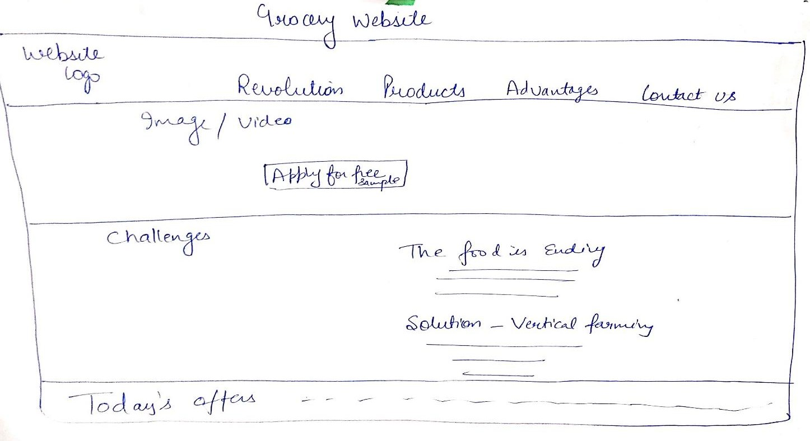

This is the basic lay out of the website that we were provided to do. The home

page of the website.

As we took the responsibility to build up the home of the Grocery website we

made it to look like this Home page(Screen shot) of it has been taken and we had

pasted it in the next page. This how we made it to look like the basic “home

page” of the Grocery website .

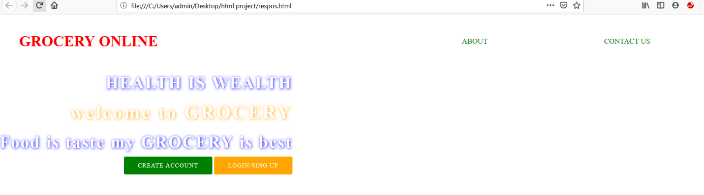

This is the first main page of our website in this page you can create a new account or you can login into our website by clicking on the Login/signup.by clicking on it you will get an another page which was look like

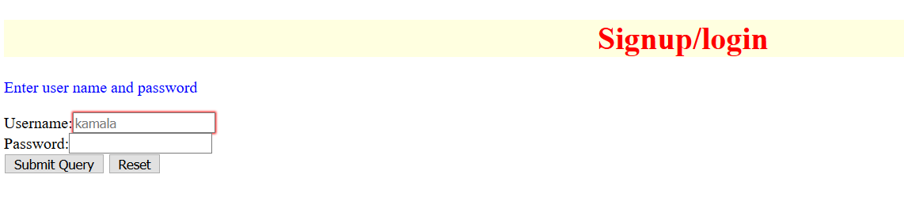

After opening our website there will be login option by clicking on it you will get a new tab. In that you should enter the user name and password to login. The login page will be look like above.

By submitting the user name and password you will be directed to our website. which look like below

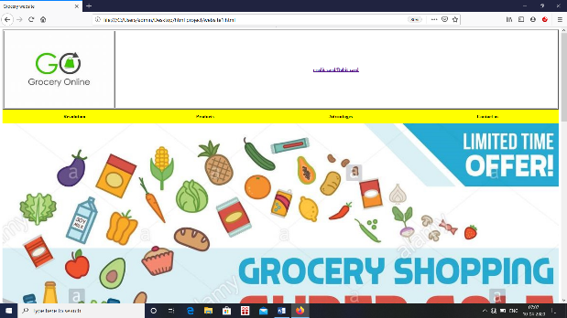.

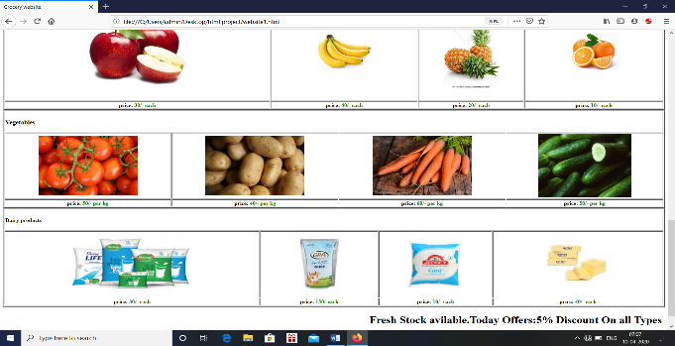

We can create an new account also by clicking on the create account we will get directed into a another page there we need to submit our details.it seems to be like below screenshot.

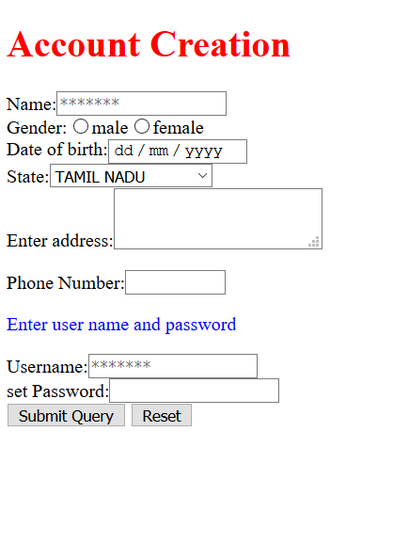

By filling the details you can create a new account and then by submitting you will be directed into our website. For any Other information you can contact us through provided Number or you send a mail to us.

We have provided credit/debit card payment for bill or you can pay money after receiving the products (cash on delivery).By clicking on the credit/debit card option you will get a page which will look like below.

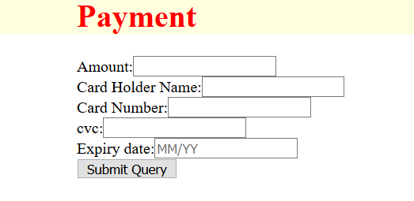

By using dropdown we have created the Revolution, Products, Advantages and Contact us .At the bottom of the page by using marquee we have provided the today’s offer also. and We attached our logo on the left corner and we added some of our products (as example)in our website page.